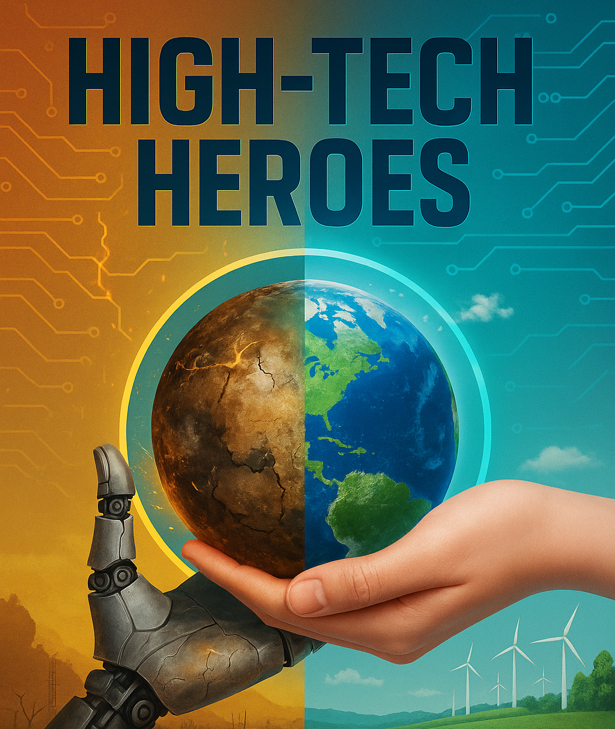

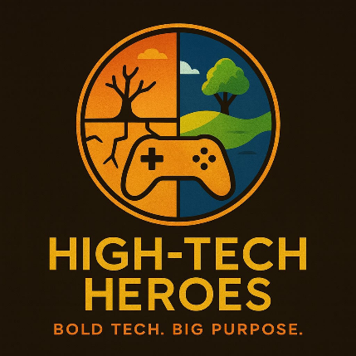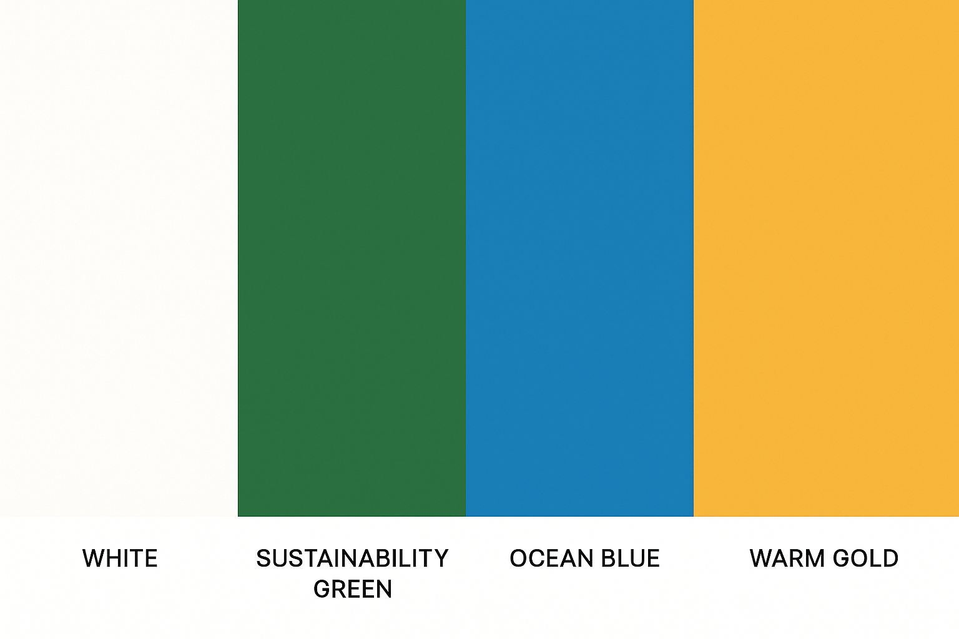

Visual assets: Book, HTH Logo (adapt to brand colors), Branded Color Palette

## 

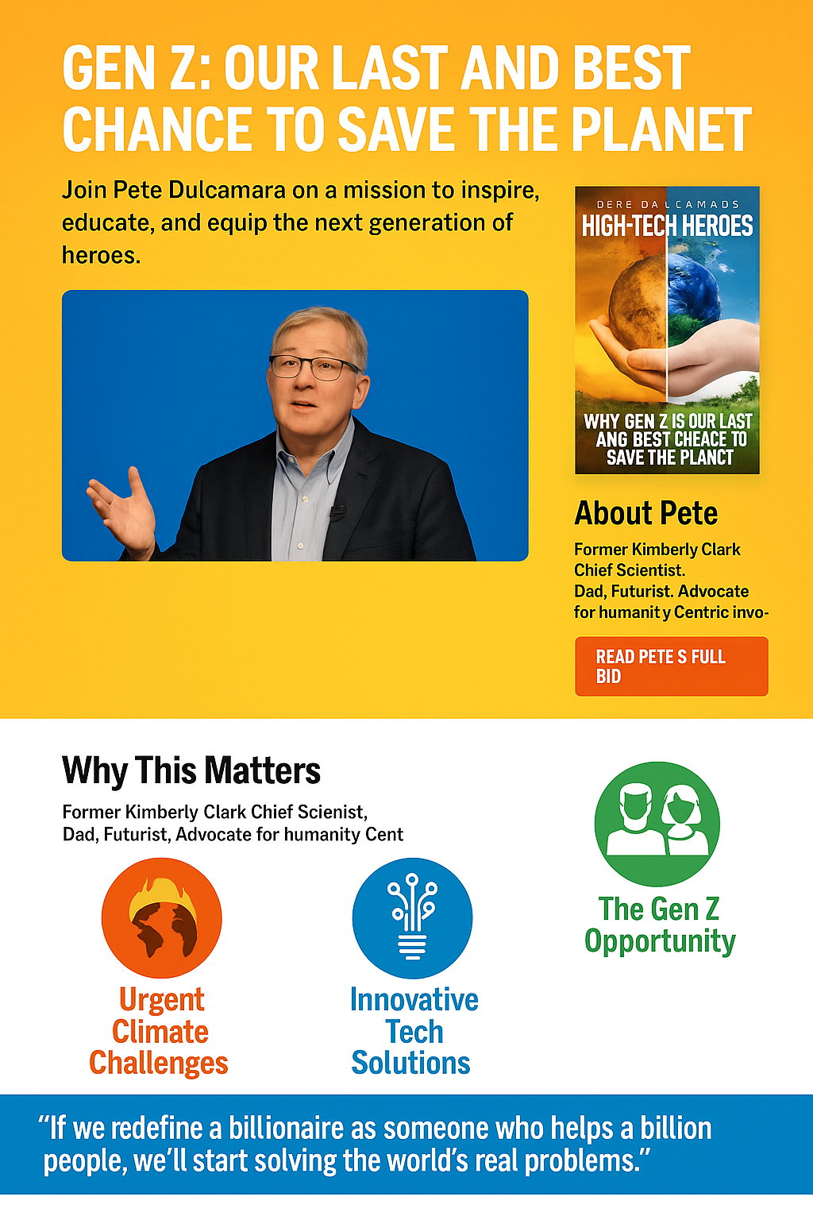

“Mockup.” The 3 circles should be aligned.

**Key Website Features:**

1. Block Hierarchy: Funnel website, Hero, CTAs (One Book, Millions)
2. 4-Page website: Homepage, About, Book Pete, Join HTH (free)
3. Four Color Palette:
   * 1. **WHITE:** Approximately #FFFFFF (pure white, clean background).
     2. **SUSTAINABILITY GREEN:** Approximately #2E7D32 (a deep, earthy green reflecting sustainability).
     3. **OCEAN BLUE:** Approximately #1E90FF (a vibrant blue reminiscent of the ocean).
     4. **WARM GOLD**: Approximately #F4A460 (a warm, golden hue with a slightly muted tone).
4. Fonts: Header font like Impact - Fesho Evolution, or Rostack (?) Secondary Font Helvectica Neue
5. Simple & easy NAV, Minimal Blurb, Mobile Optimized, Speed Test (Load Time)
6. Optimized SEO Copy throughout
7. Easy Book, Sign Up, Automated Emails
8. Multi-media: video, audio, downloads

**(Web Dev Ignore) Socials:**

1. Stream “High Tech Heroes” Podcast on YOUTUBE (Gen X, Mill) at least monthly
2. Post 3-5 posts/videos to LinkedIn (Gen X, Mill, Gen Z) network with innovators/VCs
3. Post 1-2 substantive “positive” articles/interviews/reviews per month on Substack (Mill) Feed to LinkedIn.
4. Post (60-sec shorts) daily TIKTOK, restream to DISCORD(Gen Z/Alpha)

Page 1 “Why is Gen Z Our Last and Best Chance to Save the Planet?”

Join Pete Dulcamara, former Kimberly-Clark Chief Scientist, in redefining innovation to impact a billion lives, rallying Gen Z - and save a planet …

Insert video clip into a Clip (2-min) **to be provided.**

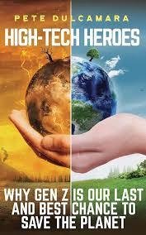

Position HTH book underneath the video. (Mobile)

Position HTH book right of the video. (Desktop)

**About the Book**

The world is changing fast, and Gen Z is rising to meet the challenge. In his cutting-edge book *High-Tech Heroes*, innovation strategist Pete Dulcamara delivers a bold call to action: use emerging technologies like AI and robotics to tackle climate change, inequality, and outdated systems NOW. You will learn about:

* Why and How Gen Z will Save the Planet
* Paper without Trees, Plastic without Petroleum, Manufacture without Waste
* AI Innovations & Workplace Integration & the “New Billionnaires”
* Data Sovereignty & Trading & Social Equity
* Sustainable Agriculture, Ocean Management

**CTA: Buy (tab) link:** <https://www.amazon.com/High-Tech-Heroes-Last-Chance-Planet/dp/1963271785/ref=sr_1_1?crid=13T4D7P2GSWCY&dib=eyJ2IjoiMSJ9.2ij60KshfnbIPJy85OgaBAzP9_dfE4Me48s3huNgnEnlZTs6mRsmnhSlCUmCnkhWcttoY0NRKY3ERibrEff38wGaM89fpcf-engaftpftMTkIXsXCvv3i6lAYRl4qDxG6cXp6UDqum4j6K4vfq1w4YQI5EtopA7JMDot77DsBds7ipfo4Loh7zL57GzgcZ2iyTqeGvFFFTI-RKBAYXDrP_Xb1kY3OUa3S913EjsrMV8.a5a-6numQ8D6ugv0opBANzZPkGbxZWzoqMmwm_H9P3c&dib_tag=se&keywords=high+tech+heroes&qid=1753636277&sprefix=%2Caps%2C318&sr=8-1>

**Read a Sample Chapter** (Lead Magnet) of “High Tech Heroes”

Add a Sample, Compelling Chapter to HTH One-Pager, Download eBook/PDF, MP3, Email Captcha Form. Build an email list, use Kit, and send a once-a-month article/newsletter.

## **(3 Entry visual points that are CTA’s)**

## **Follow: Solutions to Urgent Climate Challenges**

The planet faces a critical moment—rising temperatures, resource depletion, and environmental crises demand bold action. Pete Dulcamara, former Kimberly-Clark Chief Scientist, sources solutions that address these urgent issues head-on.  
Want to Keep Up with Emergent Technologies & Entrepreneurs? Subscribe FREE to **Pete’s HTH Substack** for timely insights on innovation and sustainability.

## **Follow: New Innovative Tech**

Breakthroughs in AI, robotics, and materials science are reshaping our future. Pete leads the charge, harnessing cutting-edge technologies to create sustainable, impactful innovations that transform lives globally.  
[**Join HTH Discord, Follow HTH on TikTok**](https://grok.com/chat/c98d1571-8948-4236-9d60-30c640449132)

## 

## **Join: The Gen Z Opportunity**

A dedicated Facebook Community dedicated to Baby Boomer, Gen X, and Early Millennial parents of Gen Z / Gen Alphas. As a Gen Z dad, Pete understands the unique challenges facing our kids. His approach to Gen Zs taking agency is novel, inspiring, and gets results.  
**Join our HTH Facebook community for collaborative innovation, networking, and driving change.**

Page 2 “About Pete D” Scientist & Gen Z Dad”

## **Visionary Leader & Innovator**

Pete Dulcamara founded Pete Dulcamara & Associates, LLC, driven by a bold mission: *“create businesses that improve people’s lives.”* At the heart of this venture lies his pioneering concept of *humanity-centric innovation*, a strategy to tackle humanity’s greatest challenges with economically viable solutions. Pete reimagines success, urging us to redefine a billionaire not by wealth, but by the billion lives that we can touch.

**CTA: Book a Discover Call with Pete. (Booking Calendar Calendly or Tidycal or similar)**

Assets: New Headshots to be provided.

## **A Legacy of Scientific Excellence**

Before launching his LLC, Pete transformed industries as Vice President of Corporate Research and the first Chief Scientist at Kimberly-Clark. He led global teams to develop breakthrough technologies, delivering iconic products like Huggies®, Kotex®, Kleenex®, and Depend®. Earlier, as a senior executive at The Dow Chemical Company, he shaped research, sustainable development, mergers, acquisitions, and new ventures across multiple business units.

Known as a *challenger, coach, and catalyst*, Pete has a proven track record of generating scientific excellence. He accelerates transformative innovations, driving revenue growth, profitability, and superior business outcomes through future-focused initiatives blending world-class science and cutting-edge research.

**Science Sector? Book a Discover Call with Pete. (Tidycal linked to Google Meets)**

## **Champion of Sustainability & Technology**

A passionate advocate for sustainability and the circular economy, Pete harnesses data science, materials science, and exponential technologies: AI, advanced robotics, and genomics to unlock disruptive solutions. His global speaking engagements inspire audiences with thought-provoking insights, powerful storytelling, and the ability to distill complex ideas into accessible, motivating messages.

Pete is a consultant at FutureBridge, [PilotLite(UK](http://www.pilotlight.org.uk)), [Midpoint Consulting](http://www.midpointconsulting.ai), [Endeavor.ai](http://www.endeavor.ai), Central Wisconsin AI Center in partnership with UW-Stevens Point, UW-Stout, Northcentral Technical College, and Greater Wausau Chamber of Commerce, amplifying his influence across education, technology, and community development. He serves on the boards of Stanford University High Impact Technology Fund, Fox Cities Chamber of Commerce, and Basset Mechanical .

**Technology Company? Book a Discover Call with Pete. (Tidycal linked to Google Meets)**

## **Academic Foundations & Personal Life**

Pete’s expertise is rooted in a Bachelor of Science in Chemistry (with minors in Mathematics and Physics) from Cameron University and in Chemical Engineering (B.S. and M.S.) from Oklahoma State University. He further honed his skills through prestigious programs: The Prince of Wales’s Business & Sustainability Programme (University of Cambridge), Tuck Executive Program on Innovation Strategy (Dartmouth College), Singularity University Executive Program, and extended education in Management Development (Indiana University) and Entrepreneurial Studies (Babson College), where he served on the curriculum development advisory council.

**Academia? Book a Discover Call with Pete. (Tidycal linked to Google Meets)**

Pete resides in Neenah, Wisconsin, with his wife, Gina, and is a proud dad to two Gen Zs. This connects him to the next generation of change-makers.

## **Speaking Engagements**

Pete’s global network spans innovation, science, and technology. Catch his recent highlights:

* [2021 TEDx Talk](https://www.ted.com/talks/pete_dulcamara_humanity_centric_innovation_redefining_the_meaning_of_billionaire)
* [2022 All Things Innovation](https://informaconnect.com/all-things-innovation/humanity-centric-innovation/)
* [2022 InnoLead Interview](https://www.innovationleader.com/video/video-kimberly-clarks-chief-scientist-on-virtual-prototyping-and-rds-future/)
* [2022 Unstuck Podcast](https://www.screendragon.com/unstuck-ep1-pete-dulcamara/)
* [2021 Humanity-Centric Innovation Article](https://www.triplepundit.com/story/2021/sanitation-humanity-centric-innovation/732266)
* [2021 Reducing Plastic Article](https://www.3blmedia.com/news/providing-better-care-smaller-footprint-how-kimberly-clark-reducing-plastics-environment)
* [2021 IRI Podcast](https://www.podbean.com/media/share/pb-wwyut-108dca9)
* [2021 Global Minds Network](https://www.youtube.com/watch?v=eyPyAcahChU)
* [2021 We Make Change Event at K-C](https://www.3blmedia.com/news/kimberly-clark)

Page 3 “Book Pete D to Speak” (Scientist & Gen Z Dad)

## TEDX Speaker Pete Dulcamara: Scientist, Kimberly-Clark Leader, Innovator, Gen Z Dad

From leading Kimberly-Clark’s global research to pioneering humanity-centric innovation, Pete’s career is a testament to transformative science. As Vice President of Corporate Research and Chief Scientist, Pete led teams developing breakthrough products for iconic brands such as Huggies®, Kleenex®, and Kotex®. Pete drove innovation in R&D, sustainability, and new ventures, shaping enterprise-wide technology strategies.

**Book a Discover Call with Pete. (Tidycal linked to Google Meets)**

**Book Pete to Speak on these Topics:**

* Why (How) Gen Z will Save the Planet
* Paper without Trees, Plastic without Petroleum, Manufacture without Waste
* AI Innovations & Workplace Integration
* Data Sovereignty & Trading
* 3D Printing, No Packaging Solutions
* The Blue Economy (Ocean management)
* Sustainable Agriculture, Clean Energy Systems
* Social Equity through AI / Tech Innovation
* The Space Economy, Circular Economy

**Book Pete Here (or take a Free 30-min Discovery Call)**

1. (Plugin) A Booking Form linked to  **(Tidycal linked to Google Meets),** when prospects book, an email notification is sent to Pete and the prospect. (For now, Pete will manually follow up).
2. Add the Free Discovery Call  **(Tidycal linked to Google Meets)**

**Download Pete’s Media Kit**

Create embed

Assets to be provided.

(Headshots, Resume, Speaking Terms & Rates, Availability, Payment, and Contact Info (payment form, cellphone, email, zoom link)



## Page 4: Join the High Tech Heroes Community

Connect with Pete and a global network of innovators shaping a sustainable future. Choose your entry point:

### **High Tech Heroes, Solutions Substack *(Millennials)***

Want to Keep Up with Emergent Technologies & Entrepreneurs? Subscribe to Pete’s Substack for timely insights on innovation and sustainability.

[Join HTH Substack](https://substack.com/) **(A link to the account will be given)**

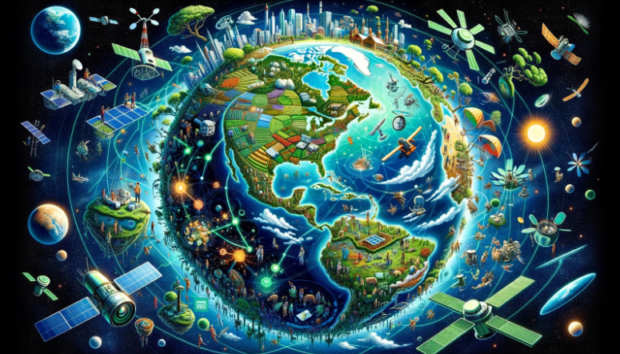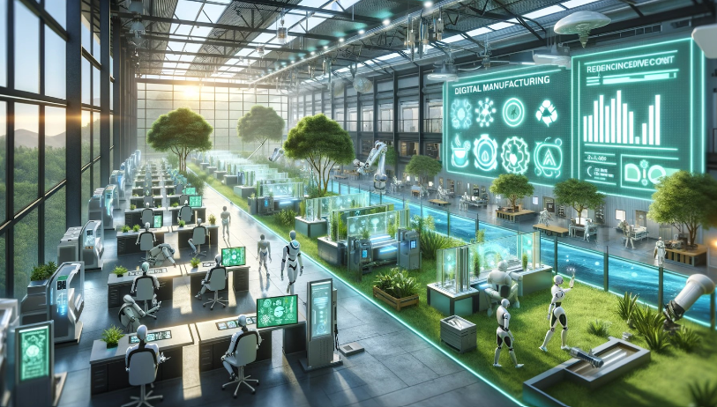

Sample Substack Images

Jacalyn to move all blog posts to Substack (timed release once a week) from: https://petedulcamara.com/blognew/

### **High Tech Heroes, Crowd Source Change *(Gen Z, Alpha)***

[Join HTH Discord](https://discord.com/), Follow HTH on TIKTOK **(A link to the accounts will be given)**

### **High Tech Heroes, Innovators Community *(Gen X, Boomers)***

Join our Facebook community for collaborative innovation, Network, and Drive Change.

[Join HTH Facebook Group](https://facebook.com/) **(A link to the account will be given)**

Website Developer

**Visuals/Assets**





* **Video** Reel will be provided, and must be embedded
* **ADD** Green banner top, position logo center, logo as brows page icon
* Dev note: **Add**: HTH Book on the right of the top video per figure 2, but **align three entry points** per figure 1
* **Add** Booking Section under Logo list.
* New headshot? (Pete Associates, update Logo)

**Funnel Layout: 4-Page Website as a Sales Funnel**

**All Assets in bold will be delivered to the web dev.**

The proposed 4-page website layout for Pete Dulcamara is designed as an effective sales and engagement funnel, guiding visitors from awareness to action while building a community. Here's the analysis:

**1. Page 1: Homepage ("Why is Gen Z is Our Last and Best Chance to Save the Planet?")**

Funnel Stage: Awareness

Purpose: Captures attention with a bold headline and Pete’s credentials, introducing his book and mission to inspire Gen Z. **The video reel** clip and book placement serve as hooks, while CTAs (Buy Book, Subscribe to **Substack**, Join **Discord/TikTok**, Join **Facebook**) drive initial engagement.

**ASSETS: Create 1) Substack, 2) Discord, 3) TIKTOK and 4) Facebook Page/Group.**

**2. Page 2: About Pete D ("Scientist & Gen Z Dad")**

Funnel Stage: Interest/Consideration

Purpose: Deepens visitor trust by showcasing Pete’s credentials, consultancy roles, and personal story, positioning him as an expert. Multiple "Book a Discover Call" CTAs target specific sectors (science, technology, academia), moving visitors toward collaboration. **(integrate** [**Tidycal.com**](http://tidycal.com) **or Calendly) Booking Plugin.**

**ASSETS: Tidycal account.**

**3. Page 3: Book Pete D to Speak ("Scientist & Gen Z Dad")**

Funnel Stage: Decision

Purpose: Converts interest into action with **a booking form** integrated to **Tidycal** and a **media kit download,** offering topics that align with Pete’s expertise and audience needs.

**ASSETS: Booking Form (web developer to source and integrate. Link to Tidycal.**

**4. Page 4: Join the High Tech Heroes Community**

Funnel Stage: Loyalty/Advocacy

Purpose: Retains and engages visitors by connecting them to community platforms **(Substack, Discord, TIKTOK, Facebook),** fostering a network of innovators.

**ASSETS: (A link/login to the accounts will be given). Web dev to integrate Substack, Discord, TIKTOK, Facebook**

**Elementor Website Layout for WordPress Developer**

This may not be helpful, so ignore if not helpful.

Below is the Elementor-compatible layout for the 4-page website, incorporating the dev notes and all specified features. The design uses the four-color palette, recommended fonts (Impact/Fesho Evolution or Rostack; Secondary Helvetica Neue), and supports multimedia, socials, and SEO optimization.

```json

{

"pages": [

{

"id": "page-1",

"title": "Why Gen Z is Our Last and Best Chance to Save the Planet",

"template": "homepage",

"sections": [

{

"type": "hero",

"settings": {

"background_color": "#FFFFFF",

"heading": {

"text": "Why Gen Z is Our Last and Best Chance to Save the Planet",

"color": "#1E90FF",

"font_family": "Impact, Fesho Evolution, sans-serif",

"font_size": "48px"

},

"subheading": {

"text": "Join Pete Dulcamara, former Kimberly-Clark Chief Scientist, in redefining innovation to impact a billion lives, rallying Gen Z - and save a planet …",

"color": "#2E7D32",

"font_size": "20px"

}

},

"elements": [

{

"type": "video",

"source": "https://www.ted.com/talks/pete_dulcamara_humanity_centric_innovation_redefining_the_meaning_of_billionaire",

"width": "560",

"height": "315",

"alignment": "left"

},

{

"type": "image",

"source": "https://www.amazon.com/High-Tech-Heroes-Last-Chance-Planet/dp/1963271785",

"alt": "High-Tech Heroes Book Cover",

"width": "300",

"alignment": "right", **(mobile version below the video)**

"condition": {

"desktop": true,

"mobile": false

}

},

{

"type": "image",

"source": "https://www.amazon.com/High-Tech-Heroes-Last-Chance-Planet/dp/1963271785",

"alt": "High-Tech Heroes Book Cover",

"width": "100%",

"alignment": "center",

"condition": {

"desktop": false,

"mobile": true

}

},

{

"type": "text_block",

"content": "About the Book\nThe world is changing fast, and Gen Z is rising to meet the challenge. In his cutting-edge book *High-Tech Heroes*, innovation strategist Pete Dulcamara delivers a bold call to action: use emerging technologies like AI and robotics to tackle climate change, inequality, and outdated systems NOW. You will learn about:\n- Why and How Gen Z will Save the Planet\n- Paper without Trees, Plastic without Petroleum, Manufacture without Waste\n- AI Innovations & Workplace Integration & the “New Billionaires”\n- Data Sovereignty & Trading & Social Equity\n- Sustainable Agriculture, Ocean Management",

"color": "#2E7D32",

"font_size": "16px"

},

{

"type": "button",

"text": "Buy the Book",

"url": "https://www.amazon.com/High-Tech-Heroes-Last-Chance-Planet/dp/1963271785",

"background_color": "#F4A460",

"text_color": "#FFFFFF",

"hover_color": "#1E90FF"

},

{

"type": "form",

"title": "Read a Sample Chapter",

"fields": [

{ "type": "text", "label": "Name" },

{ "type": "email", "label": "Email" },

{ "type": "captcha" }

],

"submit_text": "Download eBook/PDF/MP3",

"action": "email_capture",

"success_message": "Check your email for the sample chapter and monthly newsletter!"

}

]

},

{

"type": "cta_section",

"settings": {

"background_color": "#FFFFFF"

},

"elements": [

{

"type": "text_block",

"content": "Urgent Climate Challenges\nThe planet faces a critical moment—rising temperatures, resource depletion, and environmental crises demand bold action. Pete Dulcamara, former Kimberly-Clark Chief Scientist, sources solutions that address these urgent issues head-on.\nWant to Keep Up with Emergent Technologies & Entrepreneurs? Subscribe FREE to Pete’s HTH Substack for timely insights on innovation and sustainability.",

"color": "#2E7D32",

"font_size": "18px"

},

{

"type": "text_block",

"content": "Innovative Tech Solutions\nBreakthroughs in AI, robotics, and materials science are reshaping our future. Pete leads the charge, harnessing cutting-edge technologies to create sustainable, impactful innovations that transform lives globally.\nJoin HTH Discord, Follow HTH on TikTok",

"color": "#1E90FF",

"font_size": "18px"

},

{

"type": "text_block",

"content": "The Gen Z Opportunity\nA dedicated Facebook Community dedicated to Baby Boomer, Gen X, and Early Millennial parents of Gen Z / Gen Alphas. As a Gen Z dad, Pete understands the unique challenges facing our kids. His approach to Gen Zs taking agency is novel, inspiring, and gets results.\nJoin our HTH Facebook community for collaborative innovation, networking, and driving change.",

"color": "#F4A460",

"font_size": "18px"

}

]

},

{

"type": "logo_section",

"settings": {

"background_color": "#FFFFFF"

},

"elements": [

{

"type": "image",

"source": "https://www.ted.com/favicon.ico",

"alt": "TEDx Logo",

"width": "100"

},

{

"type": "image",

"source": "https://www.innolead.com/favicon.ico",

"alt": "InnoLead Logo",

"width": "100"

},

{

"type": "image",

"source": "https://www.kimberly-clark.com/favicon.ico",

"alt": "Kimberly-Clark Logo",

"width": "100"

},

{

"type": "image",

"source": "https://singularityu.org/favicon.ico",

"alt": "SingularityU Logo",

"width": "100"

}

]

},

{

"type": "booking_section",

"settings": {

"background_color": "#FFFFFF"

},

"elements": [

{

"type": "text_block",

"content": "Book Pete Dulcamara, renowned keynote speaker and innovator, to inspire your audience on sustainability and technology.",

"color": "#2E7D32",

"font_size": "20px"

},

{

"type": "button",

"text": "Book Pete to Speak",

"url": "/book-pete",

"background_color": "#1E90FF",

"text_color": "#FFFFFF",

"hover_color": "#F4A460"

}

]

}

]

},

{

"id": "page-2",

"title": "About Pete D - Scientist & Gen Z Dad",

"template": "about",

"sections": [

{

"type": "text_section",

"settings": {

"background_color": "#FFFFFF"

},

"elements": [

{

"type": "heading",

"text": "Visionary Leader & Innovator",

"color": "#1E90FF",

"font_size": "32px"

},

{

"type": "text_block",

"content": "Pete Dulcamara founded Pete Dulcamara & Associates, LLC, driven by a bold mission: “create businesses that improve people’s lives.” At the heart of this venture lies his pioneering concept of humanity-centric innovation, a strategy to tackle humanity’s greatest challenges with economically viable solutions. Pete reimagines success, urging us to redefine a billionaire not by wealth, but by the billion lives that we can touch.",

"color": "#2E7D32",

"font_size": "16px"

},

{

"type": "button",

"text": "Book a Discover Call with Pete",

"url": "/book-call",

"background_color": "#F4A460",

"text_color": "#FFFFFF",

"hover_color": "#1E90FF"

}

]

},

{

"type": "text_section",

"settings": {

"background_color": "#FFFFFF"

},

"elements": [

{

"type": "heading",

"text": "A Legacy of Scientific Excellence",

"color": "#1E90FF",

"font_size": "32px"

},

{

"type": "text_block",

"content": "Before launching his LLC, Pete transformed industries as Vice President of Corporate Research and the first Chief Scientist at Kimberly-Clark. He led global teams to develop breakthrough technologies, delivering iconic products like Huggies®, Kotex®, Kleenex®, and Depend®. Earlier, as a senior executive at The Dow Chemical Company, he shaped research, sustainable development, mergers, acquisitions, and new ventures across multiple business units. Known as a challenger, coach, and catalyst, Pete accelerates transformative innovations, driving revenue growth, profitability, and superior business outcomes.",

"color": "#2E7D32",

"font_size": "16px"

},

{

"type": "button",

"text": "Science Sector? Book a Discover Call with Pete",

"url": "/book-call",

"background_color": "#F4A460",

"text_color": "#FFFFFF",

"hover_color": "#1E90FF"

}

]

},

{

"type": "text_section",

"settings": {

"background_color": "#FFFFFF"

},

"elements": [

{

"type": "heading",

"text": "Champion of Sustainability & Technology",

"color": "#1E90FF",

"font_size": "32px"

},

{

"type": "text_block",

"content": "A passionate advocate for sustainability and the circular economy, Pete harnesses data science, materials science, and exponential technologies: AI, advanced robotics, and genomics to unlock disruptive solutions. His global speaking engagements inspire audiences with thought-provoking insights. Pete is a consultant at Pilot Light (UK), MidPoint Consulting, Endeavor AI, and Wisconsin UWSP, NCT College, and serves on boards including the Stanford University MIT Fund, Fox City Chamber of Commerce, and Basset Mechanical Innovation.",

"color": "#2E7D32",

"font_size": "16px"

},

{

"type": "button",

"text": "Technology Company? Book a Discover Call with Pete",

"url": "/book-call",

"background_color": "#F4A460",

"text_color": "#FFFFFF",

"hover_color": "#1E90FF"

}

]

},

{

"type": "text_section",

"settings": {

"background_color": "#FFFFFF"

},

"elements": [

{

"type": "heading",

"text": "Academic Foundations & Personal Life",

"color": "#1E90FF",

"font_size": "32px"

},

{

"type": "text_block",

"content": "Pete’s expertise is rooted in a Bachelor of Science in Chemistry (with minors in Mathematics and Physics) from Cameron University and dual degrees (B.S. and M.S.) in Chemical Engineering from Oklahoma State University. He further honed his skills through prestigious programs: The Prince of Wales’s Business & Sustainability Programme (University of Cambridge), Tuck Executive Program on Innovation Strategy (Dartmouth College), Singularity University Executive Program, and extended education in Management Development (Indiana University) and Entrepreneurial Studies (Babson College). Pete resides in Neenah, Wisconsin, with his wife, Gina, and is a proud dad to two Gen Zs.",

"color": "#2E7D32",

"font_size": "16px"

},

{

"type": "button",

"text": "Academia? Book a Discover Call with Pete",

"url": "/book-call",

"background_color": "#F4A460",

"text_color": "#FFFFFF",

"hover_color": "#1E90FF"

}

]

},

{

"type": "text_section",

"settings": {

"background_color": "#FFFFFF"

},

"elements": [

{

"type": "heading",

"text": "Speaking Engagements",

"color": "#1E90FF",

"font_size": "32px"

},

{

"type": "text_block",

"content": "Pete’s global network spans innovation, science, and technology. Catch his recent highlights:\n- 2021 TEDx Talk\n- 2022 All Things Innovation\n- 2022 InnoLead Interview\n- 2022 Unstuck Podcast\n- 2021 Humanity-Centric Innovation Article\n- 2021 Reducing Plastic Article\n- 2021 IRI Podcast\n- 2021 Global Minds Network\n- 2021 We Make Change Event at K-C",

"color": "#2E7D32",

"font_size": "16px"

}

]

}

]

},

{

"id": "page-3",

"title": "Book Pete D to Speak",

"template": "book",

"sections": [

{

"type": "text_section",

"settings": {

"background_color": "#FFFFFF"

},

"elements": [

{

"type": "heading",

"text": "TEDx Speaker Pete Dulcamara: Scientist, Kimberly-Clark Leader, Innovator, Gen Z Dad",

"color": "#1E90FF",

"font_size": "32px"

},

{

"type": "text_block",

"content": "From leading Kimberly-Clark’s global research to pioneering humanity-centric innovation, Pete’s career is a testament to transformative science. As Vice President of Corporate Research and Chief Scientist, Pete led teams to develop breakthrough products for iconic brands like Huggies®, Kleenex®, and Kotex®. Pete drove innovation in R&D, sustainability, and new ventures, shaping enterprise-wide technology strategies.",

"color": "#2E7D32",

"font_size": "16px"

}

]

},

{

"type": "text_section",

"settings": {

"background_color": "#FFFFFF"

},

"elements": [

{

"type": "heading",

"text": "Book Pete to Speak on these Topics:",

"color": "#1E90FF",

"font_size": "28px"

},

{

"type": "text_block",

"content": "- Why (How) Gen Z will Save the Planet\n- Paper without Trees, Plastic without Petroleum, Manufacture without Waste\n- AI Innovations & Workplace Integration\n- Data Sovereignty & Trading\n- 3D Printing, No Packaging Solutions\n- The Blue Economy (Ocean management)\n- Sustainable Agriculture, Clean Energy Systems\n- Social Equity through AI / Tech Innovation\n- The Space Economy, Circular Economy",

"color": "#2E7D32",

"font_size": "16px"

}

]

},

{

"type": "form_section",

"settings": {

"background_color": "#FFFFFF"

},

"elements": [

{

"type": "heading",

"text": "Book Pete Here (or take a Free 30-min Discovery Call)",

"color": "#1E90FF",

"font_size": "24px"

},

{

"type": "form",

"fields": [

{ "type": "text", "label": "Name" },

{ "type": "email", "label": "Email" },

{ "type": "date", "label": "Preferred Date" },

{ "type": "textarea", "label": "Message" }

],

"submit_text": "Submit Booking",

"action": "calendar_plugin",

"notification": "email_to_pete, email_confirmation_to_client"

}

]

},

{

"type": "button_section",

"settings": {

"background_color": "#FFFFFF"

},

"elements": [

{

"type": "button",

"text": "Download Pete’s Media Kit",

"url": "/media-kit.pdf",

"background_color": "#F4A460",

"text_color": "#FFFFFF",

"hover_color": "#1E90FF"

}

]

}

]

},

{

"id": "page-4",

"title": "Join the High Tech Heroes Community",

"template": "community",

"sections": [

{

"type": "text_section",

"settings": {

"background_color": "#FFFFFF"

},

"elements": [

{

"type": "heading",

"text": "Connect with Pete and a global network of innovators shaping a sustainable future. Choose your entry point:",

"color": "#1E90FF",

"font_size": "32px"

},

{

"type": "text_block",

"content": "High Tech Heroes, Solutions Substack (Millennials)\nWant to Keep Up with Emergent Technologies & Entrepreneurs? Subscribe to Pete’s Substack for timely insights on innovation and sustainability.\nJoin HTH Substack",

"color": "#2E7D32",

"font_size": "18px"

},

{

"type": "text_block",

"content": "High Tech Heroes, Crowd Source Change (Gen Z, Alpha)\nJoin HTH Discord, Follow HTH on TikTok",

"color": "#1E90FF",

"font_size": "18px"

},

{

"type": "text_block",

"content": "High Tech Heroes, Innovators Community (Gen X, Boomers)\nJoin our Facebook community for collaborative innovation, networking, and driving change.\nJoin HTH Facebook Group",

"color": "#F4A460",

"font_size": "18px"

}

]

}

]

}

],

"global_settings": {

"navigation": {

"style": "simple",

"items": [

{ "text": "Home", "url": "/page-1" },

{ "text": "About", "url": "/page-2" },

{ "text": "Book Pete", "url": "/page-3" },

{ "text": "Join HTH", "url": "/page-4" }

],

"background_color": "#2E7D32",

"text_color": "#FFFFFF",

"font_family": "Impact, Fesho Evolution, sans-serif"

},

"footer": {

"text": "© 2025 Pete Dulcamara & Associates, LLC. All rights reserved.",

"color": "#2E7D32",

"font_size": "14px"

},

"optimization": {

"mobile": true,

"speed_test": true,

"seo": true

},

"socials": {

"youtube": {

"url": "https://www.youtube.com/@HighTechHeroes",

"frequency": "monthly",

"target": "Gen X, Millennials"

},

"linkedin": {

"url": "https://www.linkedin.com/in/petedulcamara",

"frequency": "3-5 posts/videos",

"target": "Gen X, Millennials, Gen Z"

},

"substack": {

"url": "https://petedulcamara.substack.com/",

"frequency": "1-2 articles/month",

"target": "Millennials"

},

"tiktok": {

"url": "https://www.tiktok.com/@hightechheroes",

"frequency": "daily 60-sec shorts",

"target": "Gen Z, Alpha",

"restream": "discord"

}

}

}

}

```

**Recommended WordPress Theme Skin/Template**

Base Theme Selection

Theme: Astra (Free version with Pro add-ons) **Please let us know the cost of subscription before implementation.**

Theme Skin/Template Configuration

This skin/template customizes the base theme to match the mockup and design guide, ensuring a clean, minimal look with the specified palette and typography.

Global Settings

Site Layout:

- Container: Full Width (no sidebars)

- Content Width: 1200px (max)

- Typography:

- Primary Font: "Impact" or "Fesho Evolution" (fallback to Impact, bold)

- Secondary Font: "Rostack" or "Helvetica Neue" (regular weight)

- Sizes: H1 48px, H2 32px, H3 24px, Body 16px

- Line Height: 1.5

- Colors:

- Background: #FFFFFF

- Primary Color: #2E7D32 (headings, borders)

- Secondary Color: #1E90FF (links, buttons)

- Accent Color: #F4A460 (CTAs, hover effects)

- Text Color: #2E7D32 (body), #FFFFFF (buttons on colored backgrounds)

- **Spacing**:

- Padding: 20px (sections), 10px (margins)

- Button Height: 48px, Radius: 8px

Header

- Style: Sticky navigation, minimal

- Layout: Centered logo (Pete Dulcamara & Associates, LLC) + horizontal menu

- Elements:

- Logo: 150px wide (PNG/SVG, #2E7D32 text)

- Menu Items: Home, About, Book Pete, Join HTH (#FFFFFF text, #1E90FF hover)

- Background: #2E7D32

- Mobile: Hamburger menu, stack items vertically

Footer

- Style: Single row, centered

- Content: Text "© 2025 Pete Dulcamara & Associates, LLC" (#2E7D32, 14px)

- Background: #FFFFFF

- Spacing: 20px padding

Page Templates

1. Homepage ("Why is Gen Z Our Last and Best Chance to Save the Planet?")

- Hero Section:

- Full-width container

- Heading: H1, #1E90FF, 48px, centered

- Subheading: #2E7D32, 20px, italic, centered

- Two-column layout (desktop): Video (560x315px, left), Book Image (300px, right); single column (mobile): Video, then Book Image (100% width)

- Buttons: "Buy the Book" (#F4A460, #FFFFFF), Form ("Read a Sample Chapter" #2E7D32 borders, #F4A460 submit)

- CTA Section:

- Three-column grid (stack on mobile)

- Text Blocks: #2E7D32, #1E90FF, #F4A460 respectively

- Buttons: #F4A460, #FFFFFF text, #1E90FF hover

- Logo Section: Four-column grid, #2E7D32 bordered logos (100px)

- Booking Section: Centered text (#2E7D32) + Button (#1E90FF, #F4A460 hover)

2. About Pete D ("Scientist & Gen Z Dad")

- Sections: Four text blocks + Speaking Engagements

- Layout: Full-width, 20px padding

- Headings: H2, #1E90FF, 32px

- Text: #2E7D32, 16px

- Buttons: "Book a Discover Call" (#F4A460, #1E90FF hover) after each section

- Speaking List: #1E90FF links

3. Book Pete D to Speak

- Header: H1, #1E90FF, 32px

- Text Block: #2E7D32, 16px

- Topics List: #2E7D32, 16px

- Form: Centered, #2E7D32 borders, "Submit Booking" #F4A460

- Button: "Download Pete’s Media Kit" (#F4A460, #1E90FF hover)

4. Join the High Tech Heroes Community

- Header: H1, #1E90FF, 32px

- Text Blocks: Three entries (#2E7D32, #1E90FF, #F4A460, 18px)

- Buttons: #F4A460, #FFFFFF text, #1E90FF hover

Custom CSS (via Theme Customizer or Elementor)

```css

/* Button Hover Effect */

button:hover {

background-color: #1E90FF !important;

color: #FFFFFF !important;

}

/* Mobile Adjustments */

@media (max-width: 767px) {

.hero-section .column-layout {

flex-direction: column;

}

.book-image {

width: 100% !important;

}

.cta-section {

flex-direction: column;

gap: 20px;

}

}

/* Smooth Transitions */

a, button {

transition: all 0.3s ease;

}

```

Add this code to enhance responsiveness and interactivity.

Optimization (Determine Costs and Get Client Approval for on-going Subscriptions)

1. Install Base Theme: Activate Astra or GeneratePress.

2. Install Plugins: Elementor Pro, Amelia/Bookly (booking), Mailchimp/WPForms (email), Yoast SEO, WP Rocket.

3. Customize Theme:

- Use Theme Customizer to set global colors, typography, and spacing.

- Create header/footer templates in Elementor Theme Builder.

4. Build Pages: Use Elementor to drag-and-drop sections as described, applying styles from the mockup.

5. Test: Check responsiveness, load time (target <3s), and SEO with Yoast.

Assets Required

- Logo (PNG/SVG), book cover (JPEG), headshots (JPEG), TEDx video (MP4), media kit (PDF)

- Social links (Substack, YouTube, LinkedIn, TikTok, Discord, Facebook)

**More Developer Notes**

HTH Book Placement: The book image is positioned to the right of the video on desktop and below it on mobile, as specified.

Booking Section: Added under the logo section on the homepage with a "Book Pete to Speak" button linking to Page 3.

Elementor Implementation: Use the JSON structure to create sections, widgets, and settings in Elementor. Assign the four-color palette (#FFFFFF, #2E7D32, #1E90FF, #F4A460) to backgrounds, text, and buttons. Install a calendar plugin (e.g., Amelia or Bookly) for the booking form, and set up email automation (e.g., Mailchimp) for the sample chapter form.

Fonts: Test "Impact" or "Fesho Evolution" (if available) or fallback to "Rostack" or a similar bold sans-serif.

Multimedia: Embed the video and integrate social media links: Substack, Facebook Page/Group TIKTOK, Discord.

SEO: Use keywords like "Gen Z innovation," "sustainable technology," and "Pete Dulcamara" in headings and meta tags.

**Deliverables**

Below is an analysis of the required assets based on the provided layout, copy, and features, followed by a detailed list.

**Assets**

Branding and Visuals: Consistent use of the four-color palette and fonts requires logo files, book cover images, and headshots.

Multimedia: Videos, and icons for socials.

Lead Magnets and Downloads: A sample chapter in multiple formats (PDF, eBook, MP3) for email capture.

Social Media: Active accounts and content schedules for Substack, YouTube, LinkedIn, TikTok, Discord, and Facebook.

- Functional Assets: Tidycal integration, media kit, and email templates.

- SEO and Optimization: Optimized images and meta data.

**List of Assets to Collect**

**1. Branding and Visual Assets - Pete’s Team**

Create New High-resolution headshots of Pete Dulcamara (JPEG, minimum 1200x800px)

High-Tech Heroes book cover image (JPEG/PNG, 300x400px for desktop, 100% width for mobile)

- Favicon for website (ICO, 16x16px and 32x32px)

- Font files or links (e.g., Impact, Fesho Evolution, or Rostack; ensure licensing for web use)

**2. Multimedia Assets - Pete’s Team**

- Edited 2-min video clip (Hero)

High-Tech Heroes Podcast audio files (MP3, at least one episode for YouTube streaming)

Sample images for Substack articles (JPEG, 800x600px, minimum 5 images)

Web Dev to grab from Google images: Logo icons for TEDx, InnoLead, Kimberly-Clark, SingularityU (PNG, 100x100px each)

**3. Lead Magnets and Downloadable Content - Pete’s Team**

- Sample chapter of "High-Tech Heroes" (PDF, eBook format, MP3 narration)

- Content: Compelling chapter (e.g., "Why will Gen Z Save the Planet?")

- Design: Branded with color palette, Pete’s bio, and call-to-actions

- High-Tech Heroes One-Pager (PDF, 1-2 pages) with sample chapter excerpt

- Media Kit (PDF)

- Headshots, resume, speaking terms & rates, availability, payment form, contact info (email, Google Meet)

**4. Social Media Assets - Pete’s Team**

- HTH Substack Account: Create account (https://petedulcamara.substack.com/) and migrate blog posts from https://petedulcamara.com/blognew/ (timed weekly release)

- YouTube Channel: "High Tech Heroes" account setup, monthly podcast streaming link

- LinkedIn Profile: Pete’s profile link (https://www.linkedin.com/in/petedulcamara) with 3-5 post/video templates

- TikTok Account: "hightechheroes" account setup, daily 60-sec short video templates

- Discord Server: "High Tech Heroes" server setup, integration with TikTok restream

- Facebook Group: "High Tech Heroes Innovators Community" group setup, initial post template

5. F**unctional and Operational Assets - Web Dev**

- TidyCal Booking Calendar Plugin Data

- Pete’s availability schedule (e.g., Google Calendar export)

- Email notification template for Pete and confirmation template for clients

- Email Automation Kit

- Kit integration

- Template for monthly newsletter/article

- Captcha form code for sample chapter download

- SEO Metadata

- Generate Keywords (e.g., "Gen Z innovation," "sustainable technology," "Pete Dulcamara")

- Generate Meta titles and descriptions for each page

**6. Development and Optimization Assets - Web Dev**

- Optimized images (compressed JPEG/PNG, under 100KB each)

- Speed test report baseline (e.g., Google PageSpeed Insights)

- Mobile-responsive design mockups (sketch or screenshot for developer reference)

**Notes for Collection**

Align ALL social media profiles: headshots, description, bio

Prioritization: Start with branding (logo, book cover) and multimedia (2-min video clip, podcast) to ensure visual readiness. Social accounts should be set up early for content scheduling.

Collaboration: Pete to work with Jacalyn to migrate blog posts to Substack.

Open TIKTOK and Discord accounts. Pete to provide new headshots, availability, and media kit content.

Technical Support: Jordan (Pete’s Team) to shoot video, edit and add captions.